Title (Times New Roman 14-Heading Centred)
Author1, Author2, ..., Authorn (Times New Roman 12-normal centred)

1Institute Name, Institute Address, Country, e-mail address (Times New Roman 10-normal center justified)
2Different Institute Name, Different Institute Address, Country, e-mail address (Times New Roman 10-normal)
...
nDifferent Institute Name, Different Institute Address, Country, e-mail address (Times New Roman 10-normal)
(Dated: September 12, 2007)

I. Introduction (Times New Roman 10-bold centre justified capital)
(Text in Times New Roman 9-normal justified and indented 0.5 cm - see example below)
The problem of hail formation and hail forecasting had been faced by several authors (Fawbush and Miller, 1953; Ludlam, 1958; Prodi and Wirth, 1973; Morgan, 1973), nevertheless, even if the general understanding of this phenomenon is highly increased, it still presents some open questions mainly because its occurrence involves both mesoscale and microphysical processes ...

II. Presentation of Research (Times New Roman 10-bold centre justified capital)
(Text in Times New Roman 9-normal justified and indented 0.5 cm - see example below)
The effects of mixing ratio on hailstone growth are analyzed using a simple analytical model where it is assumed that the growth process is entirely due to the collection of supercooled droplets. With this assumption, the growth equation becomes (Mason, 1971; Knight and Knight, 2001)
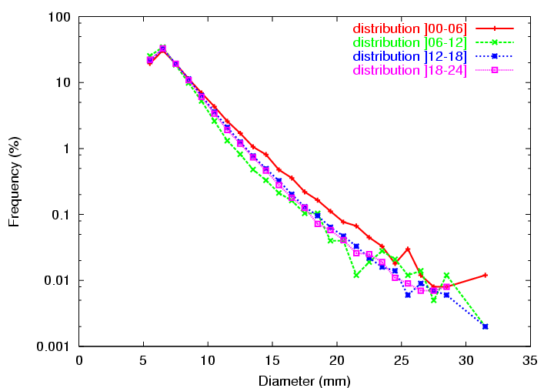
FIG. 1: Caption text in Times new Roman 8 justified Caption of the table should be kept short.

Column 1 | Column 2 | ... | Column n
TABLE I: Text of the caption in Times new Roman 8 justified. Caption of the table should be kept short.

III. Results and Conclusions (Times New Roman 10-bold centre justified capital )
(Text in Times New Roman 9-normal justified and indented 0.5 cm - see example below).
In this, work it is shown that the average mixing ratio vertical profile over the Friuli Venezia Giulia plain is not constant, neither in the various months of the year nor in the four times-of-the-day. In particular, the amount of mixing ratio increases from January to August and from morning (06 UTC) to night (00 UTC), being the last differences particularly evident in July, August and September.
Taking into account these differences and using a simple analytical model for hail growth, it has been possible to reproduce the order of magnitude of the observed differences in the shape of the hailstone size distribution in the four times-of-the-day...

IV. Aknowledgments
(Times New Roman 10-bold centre justified capital)
(Text in Times New Roman 9-normal justified - see example below)
The authors would like to thank all the volunteers who, since 1988, contribute to the collection of the hailpads. Without their effort, this work ...

V. References
(Times New Roman 10-bold centre justified capital)
(Reference text in Times New Roman 9-normal justified and indented 0.5 cm - see example below).
FamilyName N., FamilyName N., Year: Title. Journal_name_in_italic, volume first pagenumber– last pagenumber
Giaiotti D. B., Stel F., 2006: Environmental Variables Affecting the Hailstone Size Distribution at the Ground. Atmos. Res., 20 109-112.

